Assignment -19.3

Task 8: Write a MapReduce program that takes the output of Task 5 (refer session 7, assignment 1) as input, and produce output which is sorted on the total units sold. You may use a single reducer for the sorting. Use Sequence File formats as an output of Task 5 and as input for this task.

//mapper

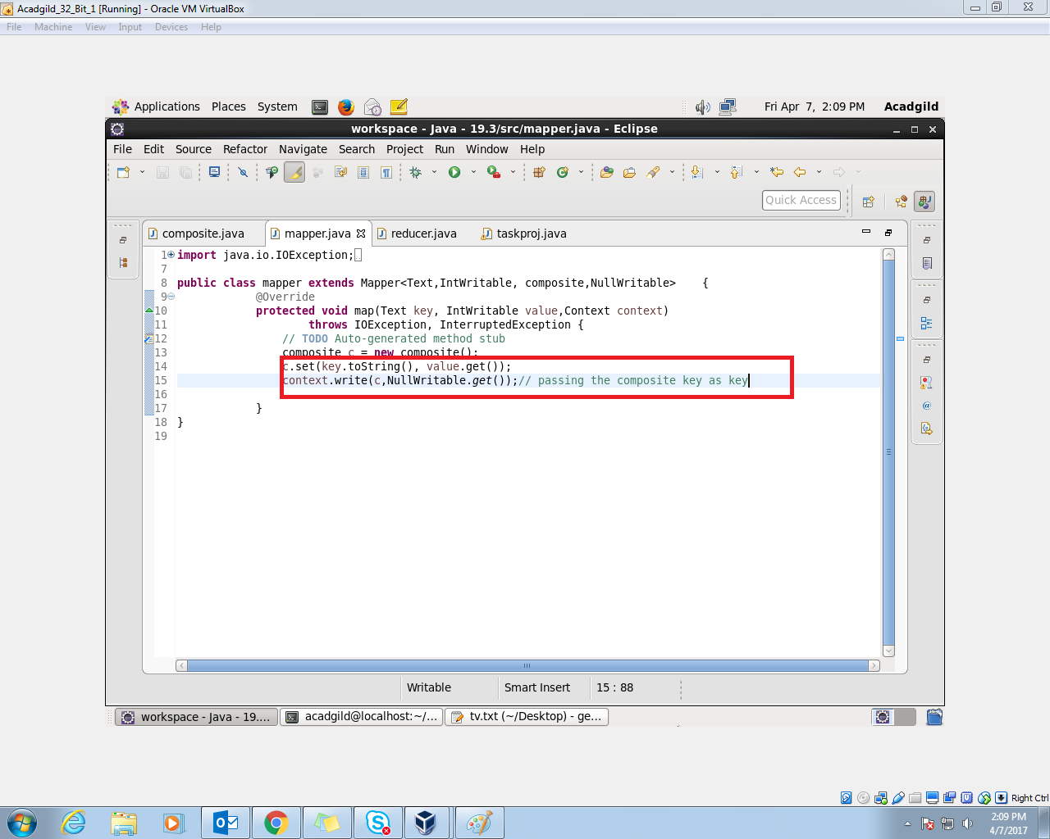

//composite key

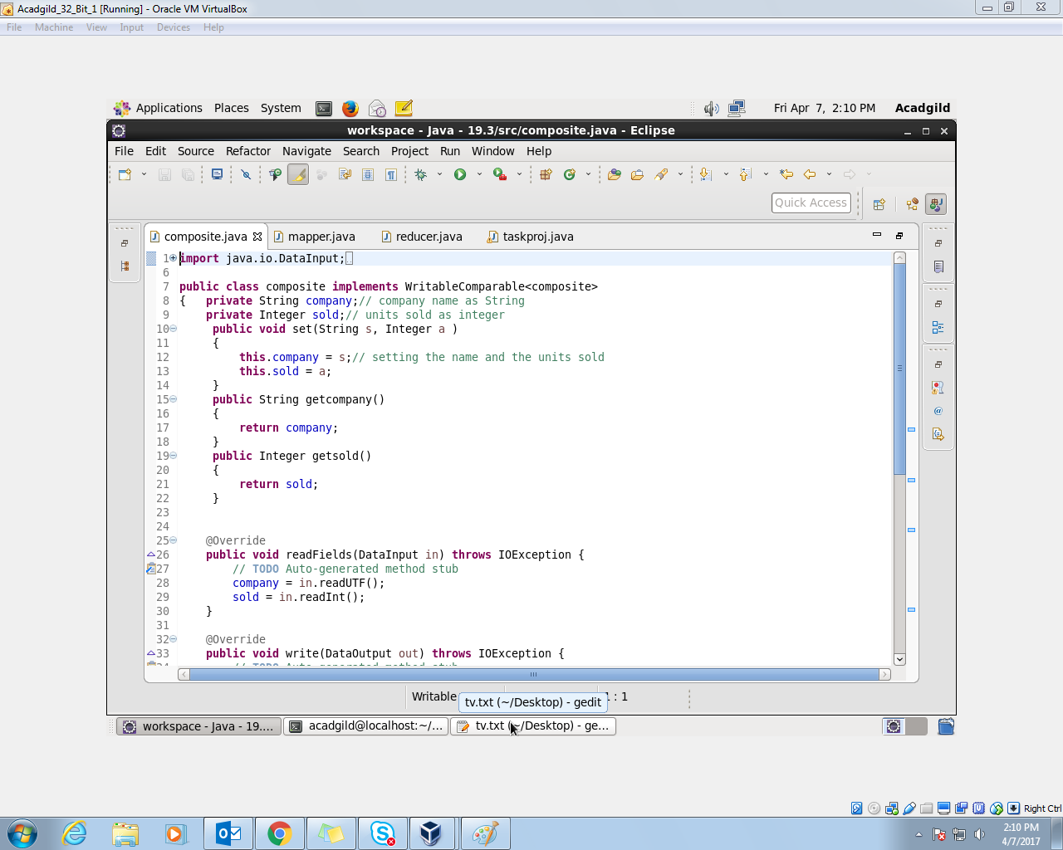

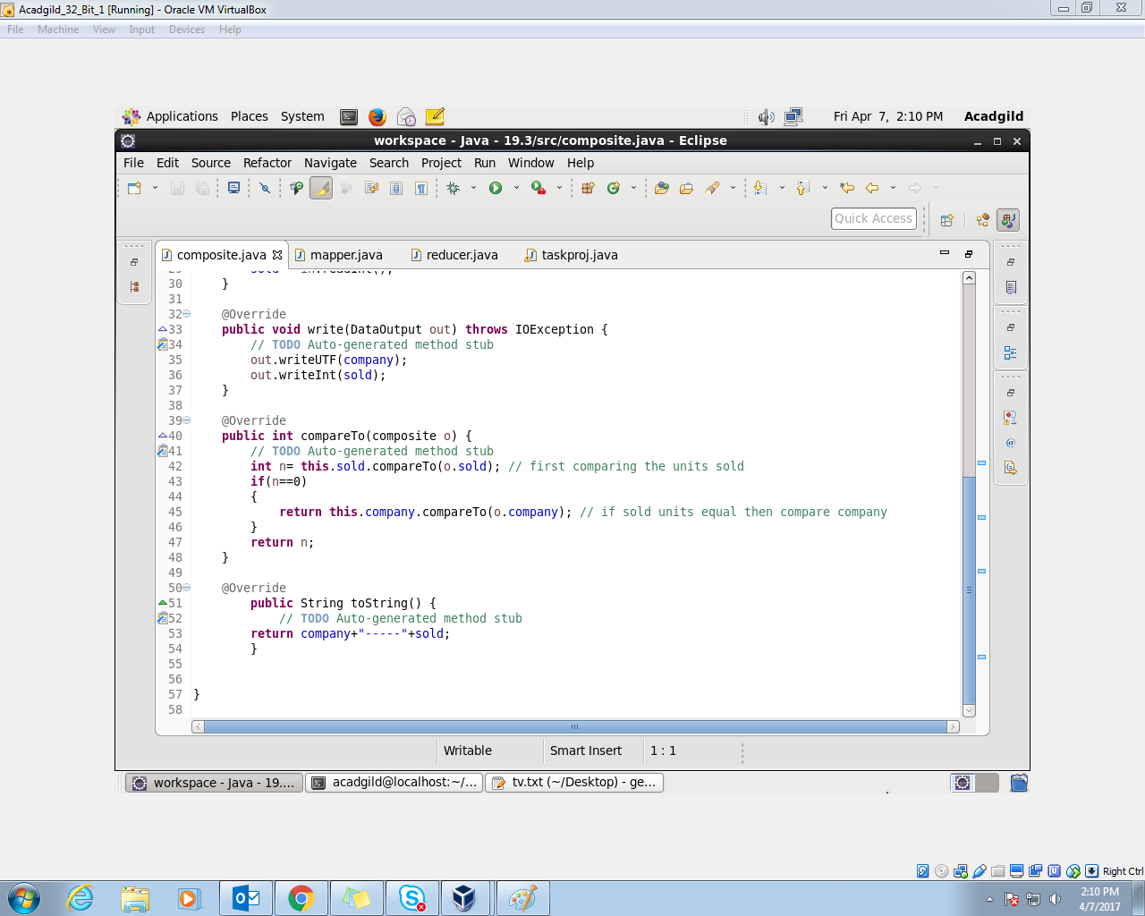

//reducer

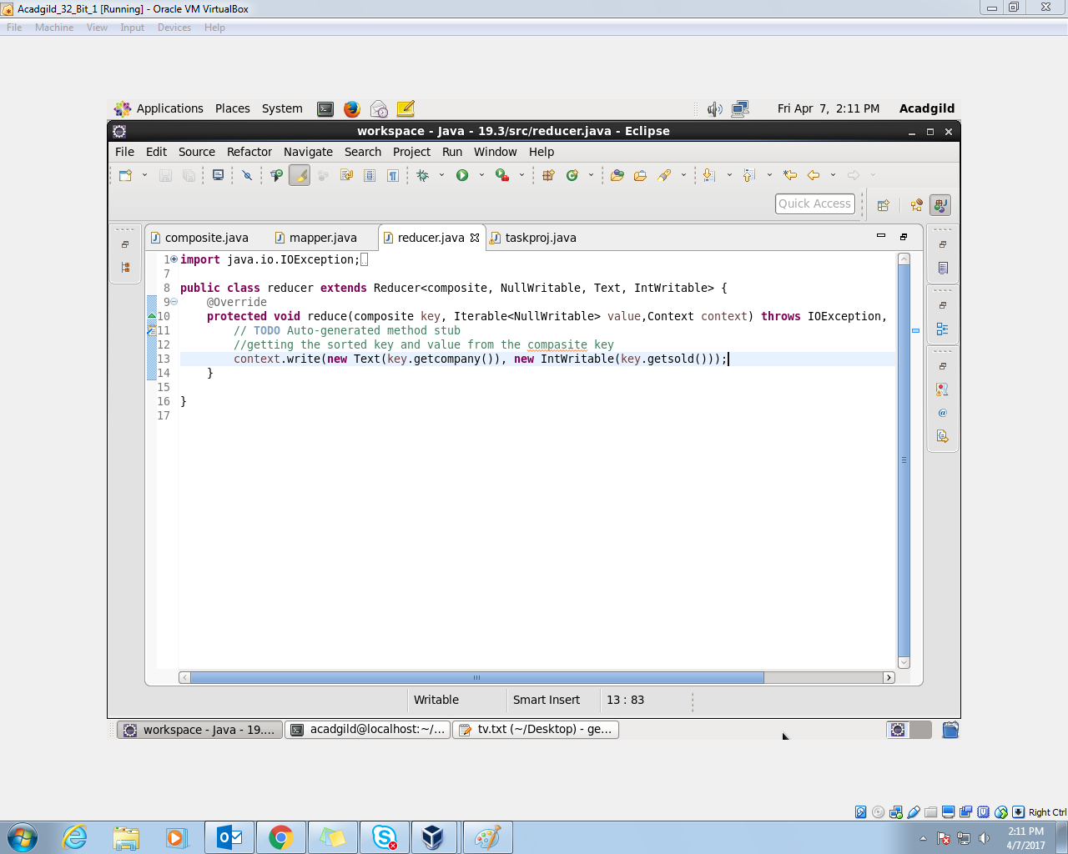

//driver

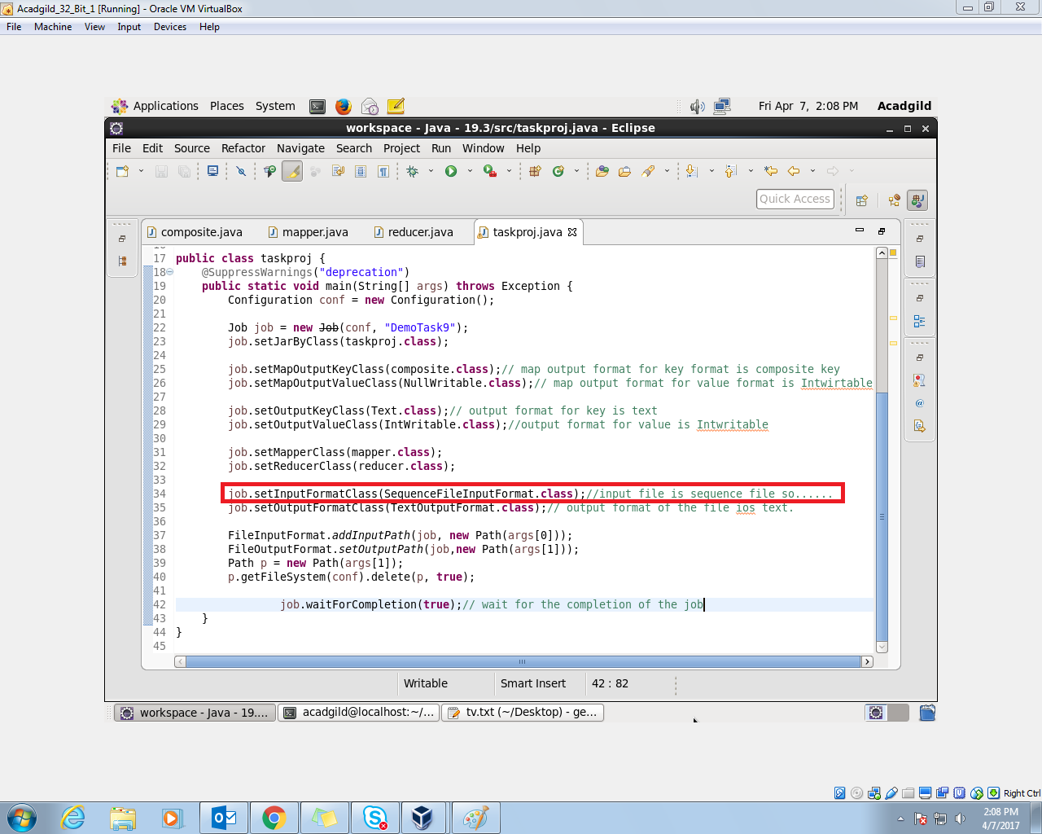

//implementation

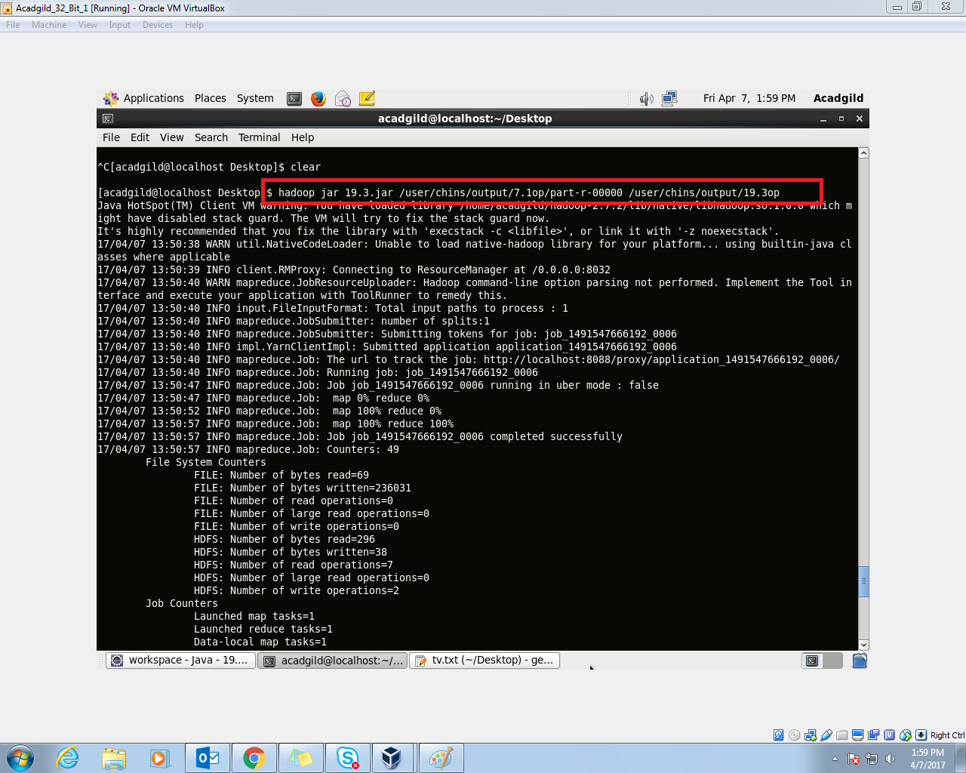

//input

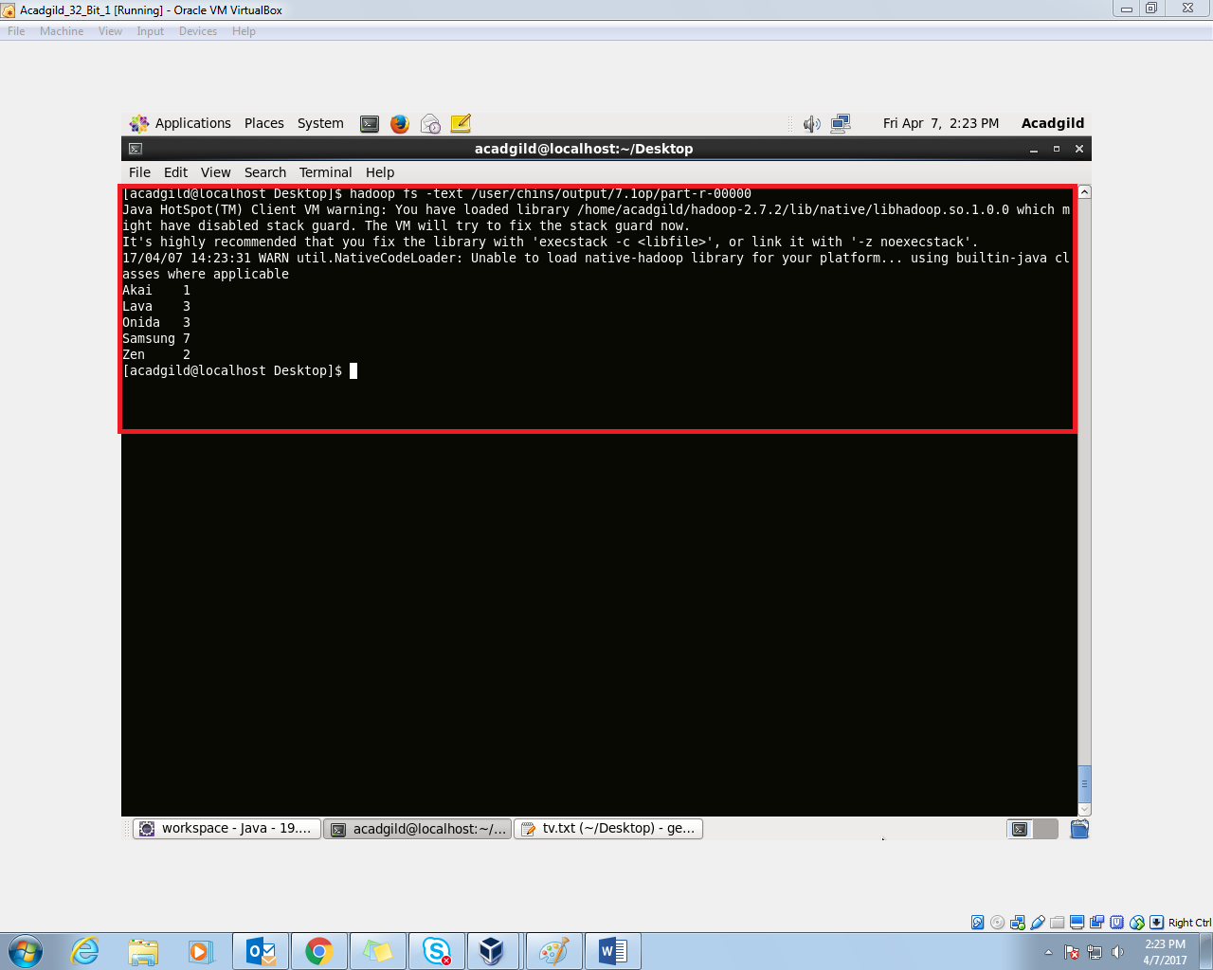

//output

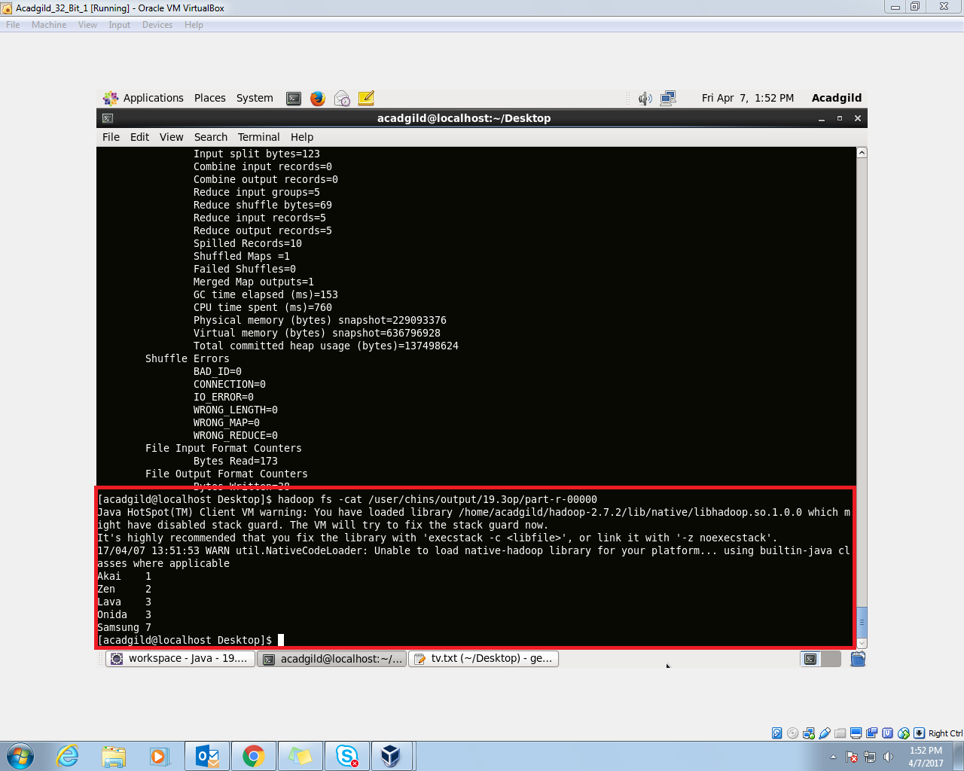

// company names are sorted in descending order if the sold units are same.